**Assignment 12- Project- US crime analysis:**

1. Write a MapReduce/Pig program to calculate the number of cases investigated under each FBI cod

OUTPUT:



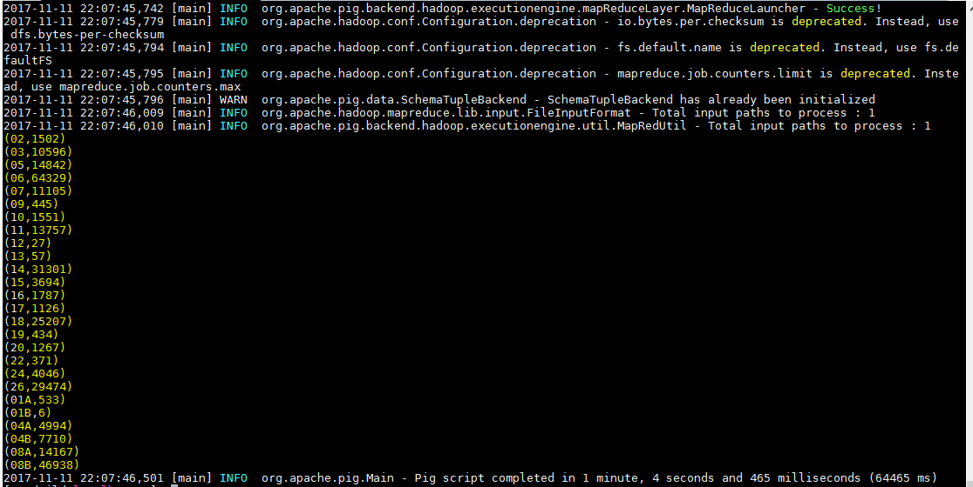

2. Write a MapReduce/Pig program to calculate the number of cases investigated under FBI code 32.

**OUTPUT:**



**Since there is no record for fbi_code : 32**

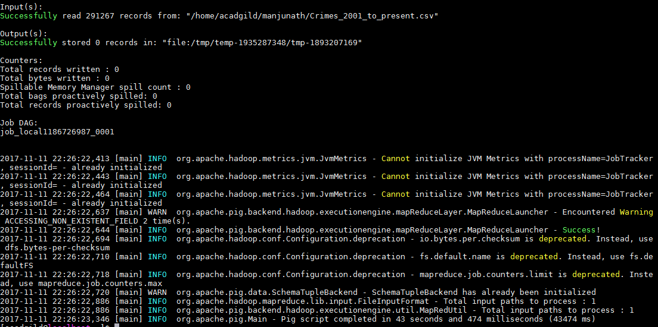

**If the fbi_code is 01A**

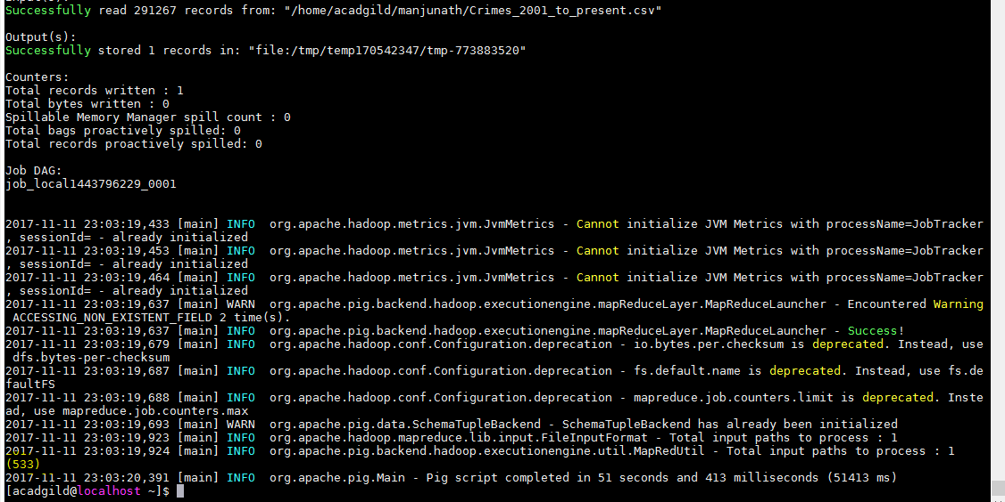

1. Write a MapReduce/Pig program to calculate the number of arrests in theft district wise.

OUTPUT:



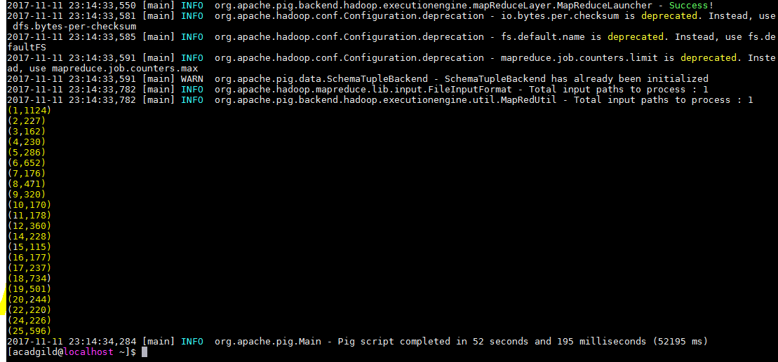

1. Write a MapReduce/Pig program to calculate the number of arrests done between October 2014 and October 2015.

**OUTPUT:**

